Robert J. McGarvey Elementary School

Principal: Mike Gulden Vice-Principal: Wilbert Villalta Phone: 916-793-3400 mgulden@egusd.net wvillalt@egusd.net Fax: 916-689-7640

“Wonder-Full” Wednesday Newsletter!
Wednesday, August 26, 2020

GRIFFIN NEWS

Classroom Level Parent Surveys About Distance Learning Thank you Griffin
families for your patience and understanding as we began a new school year using a brand new concept of Distance Learning. Your informal feedback has been both useful and appreciated. For our B, C & D track families, in the next couple of days you can expect your child’s teacher to send you a link to a survey. For our A track families, the surveys will go out during the week of September 14. The purpose of the survey is to gather feedback to help each classroom teacher understand areas of strength and those needing attention. Your responses will go straight to your child’s teacher, who will use the information to guide their planning. Your participation is appreciated and your feedback valued.

Show Your Spirit! Please encourage your Griffins to show their spirit during the week! Even though we are in Distance Learning, we are still celebrating Tie-Dye Tuesdays, Where Will We Go Wednesdays, and Griffin Gear Fridays. Show your spirit by wearing your anything tie-dye on Tuesday, your college gear on Wednesday, and your McGarvey blue on Friday!

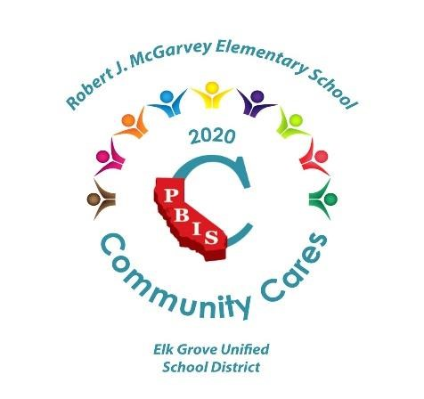
Congratulations! We are excited and proud to announce that the California PBIS Coalition has recognized Robert J. McGarvey Elementary School for our outstanding contribution of support and care during the unprecedented COVID-19 pandemic and resulting disruptions to school. If you have time, you are invited to read the congratulatory letter. PBIS Coalition.pdf The PBIS Coalition also recognized our partners; EGUSD Food and Nutrition Services and the Sacramento Educational Cable Consortium.

Distance Learning Information Helpful Links –
- Chromebook Helpful Tips - Chromebook Tutorial for Distance Learning Families
- Back to School Night Slide Show - McGarvey Back to School 20/21
- FAQs to Distance Learning - https://sites.google.com/egusd.net/family-resources/faqs -
- 2020-2021 Student-Parent-Faculty Distance Learning Handbook - Distance Learning HANDBOOK
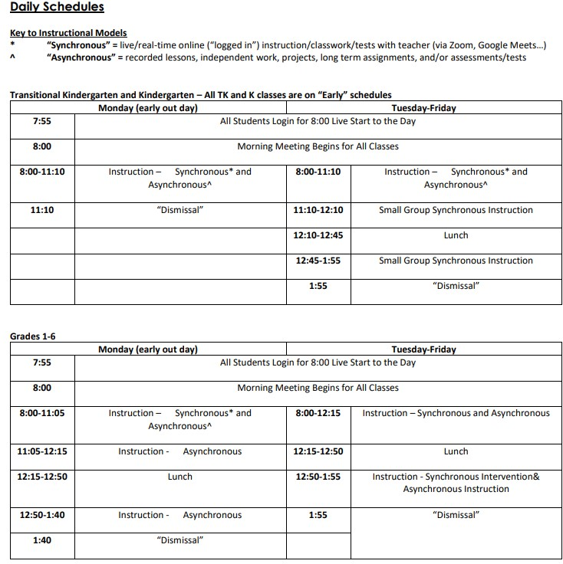

EGUSD NEWS

Changes to EGUSD Meal Service Operation
Due to current air quality conditions and to better accommodate families during distance learning, the Elk Grove Unified School District (EGUSD) will transition to a new food and nutrition service model effective tomorrow, August 26th. These changes do not impact the meal services offered at Cosumnes River ES, Pleasant Grove ES or C.W. Dillard ES.
Tomorrow, Wednesday (8/26), during the 6:45 a.m. – 8:00 a.m. service, families will receive all breakfast and lunch meals for the following days: Wednesday, Thursday, and Friday.
Next week, starting on Monday, August 31st, the meal service will be as follows:
- Monday (8/31) – Families will receive breakfast and lunch for Monday during the 6:45 a.m. – 8 a.m. meal service.
- Tuesday (9/1) – Families will receive meals for Tuesday, Wednesday, and Thursday during the 6:45 a.m. – 8:00 a.m. meal service.
- Friday (9/4) – Families will receive breakfast and lunch for Friday during the 6:45 a.m. – 8:00 a.m. meal service.
- For the week initiating on Monday, September 7th (Labor Day Holiday), there will be no meal service on that Monday. Meal service will recommence on Tuesday, September 8th.
From September 8th onward, EGUSD Food & Nutrition Services will provide the following new Curb-Side Meal service:
- Two (2) pick up days a week, Tuesdays and Fridays
o Tuesdays, families will receive breakfast and lunch for Tuesday, Wednesday, and Thursday o Fridays, families will receive meals for Friday and Monday
- Two (2) service windows where families will be able to pick up meals
_{o} Early Service Window: 6:45 a.m. - 8:00 a.m.
_{o} Midday Service Window: 11:30 a.m. – 12:30 p.m.
Families can continue to pick up meals at Robert J. McGarvey. All EGUSD families are eligible to participate. Children eligible for free or reduced-price meals will be able to pick up meals at no cost. Paid eligible families can pick up meals for $1.75 for breakfast meal and $2.75 for lunch.

ScholarShare529 is a program run through the California State Treasurer’s Office.
ScholarShare529 helps families save for higher education. They have a Matching Grant Program where they give additional help to families to kick start their saving goals. With this program, eligible families get a $200 match to their initial contributions to boost their savings, making college more attainable. We believe Families of the Elk Grove Unified School District would benefit from this program.

Studies have shown that even children with college savings of less than $500 are three times more likely to enroll in higher education, and four times more likely to graduate, than those without a college savings
account. If you are interested in more information about this savings program, please visit the ScholarShare529 website at https://www.scholarshare529.com/buzz/matching-grant/

IMPORTANT DATES

Track Change Day – Goodbye B Track
- Wednesday, August 26
- B Track returns to Distance Learning on September 14
Labor Day-No School
- Monday, September 7

Track Change Day – Goodbye C Track
• Wednesday, September 16

Have a great week, Griffins!

